

VH-TRUMAN BANQUETTE

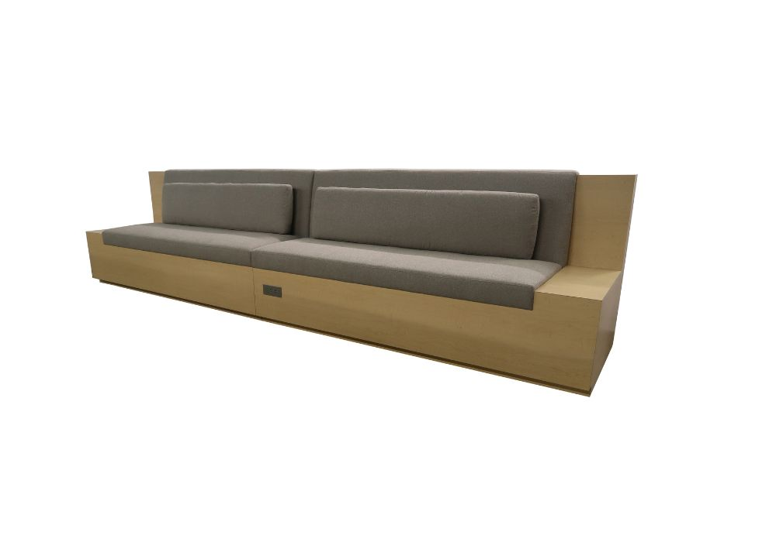

COCOTRU | TRUMAN BANQUETTE | 16 YARDS | 150”W | 30” D | 36” H | 19”SH | 24”SD
*ALL VH PRODUCTS CAN BE CUSTOMIZED TO FIT YOUR SPECIFIC NEEDS*

