
VH-ARCHIE SOFA
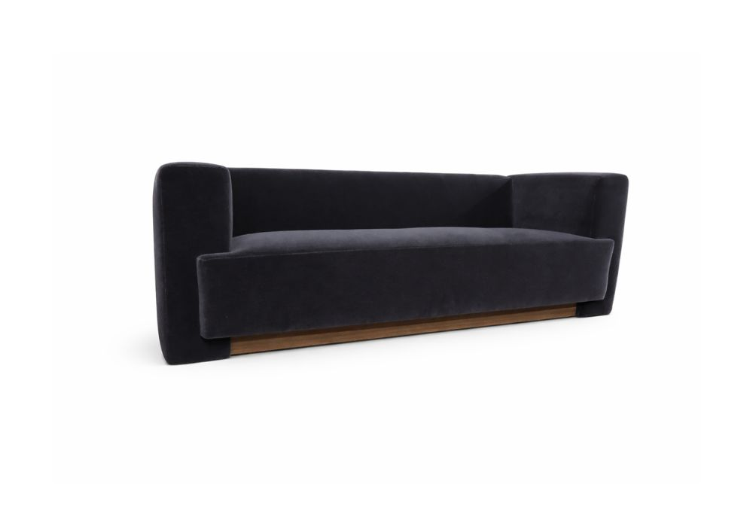

SKU | STYLE | YDS | W | D | H | SW | SH | SD | AH
COCOARCH | ARCHIE SOFA | 15 | 84” | 30” | 29” | 68” | 17” | 24” | 29”

