
VH-PASEO SOFA
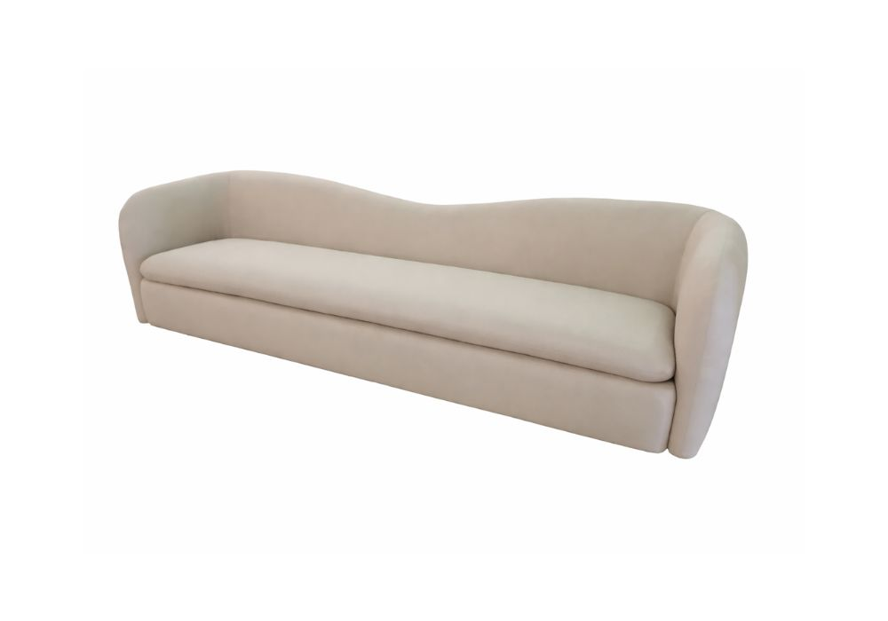

SKU | STYLE | YDS | W | D | H | SW | SH | SD | AH
COCOPASE | PASEO SOFA | 23 | 120” | 33.5” | 31.5” | 108” | 17” | 24” | 31.5”

