
VH REACTION BANQUETTE SOFA
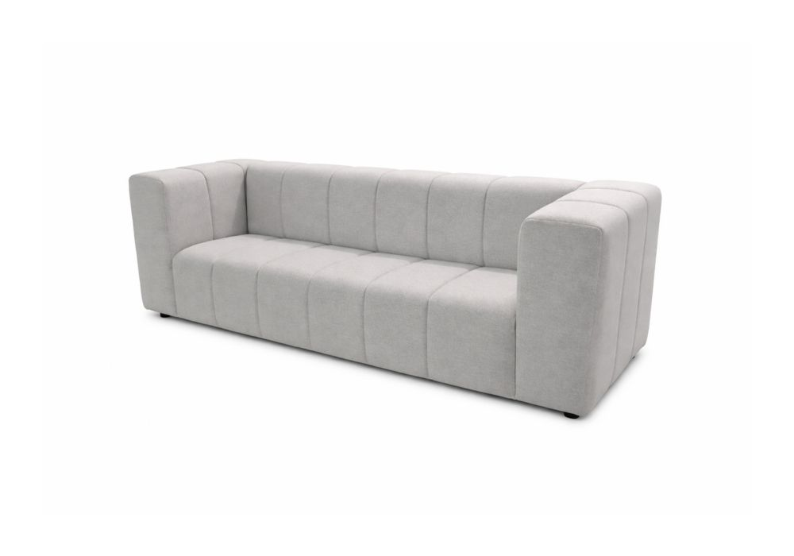

SKU | STYLE | YDS | W | D | H | SW | SD
COCOREACT | REACTION-BANQUETTE SOFA | 15 | 94” | 36” | 29” | 76” | 25”

*ALL VH PRODUCTS CAN BE CUSTOMIZED TO FIT YOUR SPECIFIC NEEDS*

