
VH DYNA SOFA

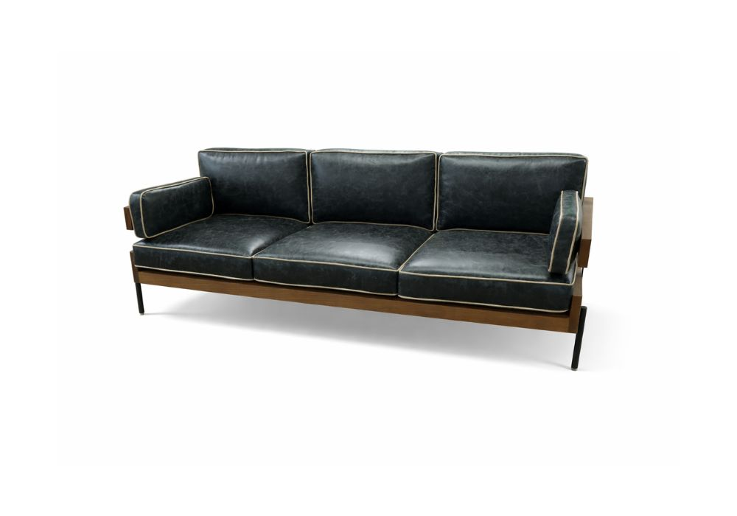

SKU | STYLE | YDS | W | D | H | SH | SD | AH
COCODYN | DYNA SOFA | 22 | 82” | 32” | 31.5” | 17” | 20” | 25”

